Medical Marijuana Clinical Trials: Preempted by Politics

Previously published on Appliedclinicaltrials
There has been a lot of debate on the therapeutic use of marijuana. There are currently 24
states that have legalized marijuana for medical use, 1and most recently, two states, Washington and Colorado, have legalized marijuana for recreational use.2 While there is literature that suggests benefits of marijuana for medicinal use, particularly in animal models, funding and approvals for therapeutic marijuana use in clinical trials is limited. For example, Dr. Sue Sisley, a psychiatrist at the University of Arizona, lost her job over a proposal to study marijuana on posttraumatic stress disorder patients.3 Donald Abrams, MD, Cancer and Integrative Medicine Specialist at the UCSF Osher Center for Integrative Medicine at Mount Zion, and Chief of Hematology and Oncology at San Francisco General Hospital, has experience in running therapeutic marijuana clinical trials, and will elaborate on his experiences and opinions in this interview.
What kinds of challenges do you face when proposing human marijuana trials?
It all started back in 1992, when I was challenged to study cannabis as an appetite stimulant in AIDS wasting syndrome. Through my experience, I learned that studying cannabis requires a lot of different approvals; every time I propose a trial, seven or eight different bodies have to weigh in on the study. You have to obtain local approvals from medical advisory committees as well as the Dean’s office, and you have to get IRB approval from the University. When dealing with the federal government, since marijuana is a controlled substance, I have to obtain approval from the Research Advisory Panel of California.
Another challenge involves funding; my most recent clinical trial, which evaluates cannabis versus placebo in sickle cell patients with chronic pain, is funded by the NIH Heart Lung and Blood Institute (NHLBI). Prior studies have been funded by the University of California Center for Medicinal Cannabis Research or the National Institute on Drug Abuse (NIDA). NIDA provides cannabis for clinical trial use. However, NIDA has a mandate to support research on substance abuse, and not therapeutic use of controlled substances. In trials that focus on demonstrating the medical benefits of cannabis, the FDA needs to be involved, and they typically require an IND submission. Lastly, federal and local Drug Enforcement Administration agencies (DEA) need to approve the protocol and conduct an on-site evaluation (i.e., how is the cannabis stored in the facility, are there locks, is there an alarm, etc.) and I have to acquire a Schedule 1 license in order to prescribe the cannabis. The process is arduous and time-consuming, which deters medical investigators from conducting therapeutic clinical trials on marijuana.
Are the biopharmaceutical industry and government hesitant about exploring therapeutic marijuana use in clinical trials? If so, why?
There are several challenges that biopharmaceutical companies face when creating new therapies that use marijuana. Marijuana is a plant, and it can’t be patented, however, some companies have marketed approved licensed therapies, such as Marinol (Abbott Labs) and Nabilone (Meda Pharmaceuticals). Other companies, (such as GW Pharmaceuticals) are researching and developing a whole plant extract and they are evaluating these compounds in clinical trials to treat diseases (epilepsy, oncology pain, diabetes, psychiatric disorders and inflammation). There are more than 400 chemicals in marijuana that may produce therapeutic effects.
Other companies (Sanofi-Aventis) have tried and failed at introducing compounds that intervened with endocannabinoids (bodily produced cannabinoids) and CB1/CB2 receptors in the brain and immune system. Rimonabant was an agonist for the CB1 receptor, and was developed to treat obesity. The compound was initially approved in Europe and was subsequently suspended from the market due to serious psychiatric problems, such as depression and suicide. Biopharmaceutical companies have to be careful about intervening with nature and blocking cannabinoid receptors.
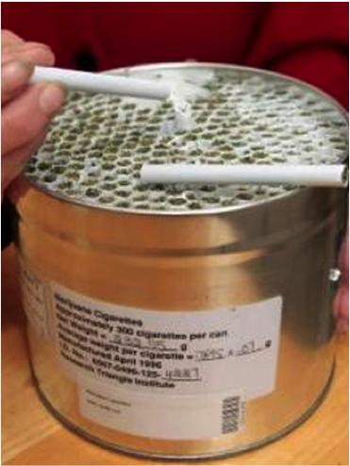Can you describe the results of your research on human trials with therapeutic marijuana use? Are there observable medical benefits?
I did cannabis clinical research for a number of indications. I did a study with HIV-related neuropathy and another in patients with chronic pain on opioid analgesics. Cannabis was effective. If one is trying to minimize the use of opiates in cancer patients in order to minimize the risk of addiction, we may want to introduce cannabis as an adjunctive or alternative therapy. Sanjay Gupta has been doing much to advance the study of therapeutic cannabinoids for the treatment of epilepsy in children, and multiple sclerosis. 4
There are a number of areas where cannabis can be investigated including posttraumatic stress disorder; I was just talking to some friends in Colorado and they observe that there are an increased number of veterans appearing in wheelchairs not to be treated by the VA, but to access cannabis. The book,Marijuana Gateway to Health: How Cannabis Protects Us from Cancer and Alzheimer’s Disease, provides medical evidence on the subject, and the political situation affecting cannabis research.
References:
[1] http://medicalmarijuana.procon.org/view.resource.php?resourceID=000881
[2] http://www.huffingtonpost.com/2014/07/08/washington-marijuana-sales_n_5545187.html
[3] http://www.nytimes.com/2014/08/10/us/politics/medical-marijuana-research-hits-the-wall-of-federal-law.html?hpw&action=click&pgtype=Homepage&version=HpHedThumbWell&module=well-region%C2%AEion=bottom-well&WT.nav=bottom-well&_r=2
[4] http://www.cnn.com/2014/03/05/health/gupta-medical-marijuana/
[5] Image courtesy of: http://www.thomhartmann.com/users/ddc/blog/2012/12/ole-miss-home-medical-marijuana-lab

